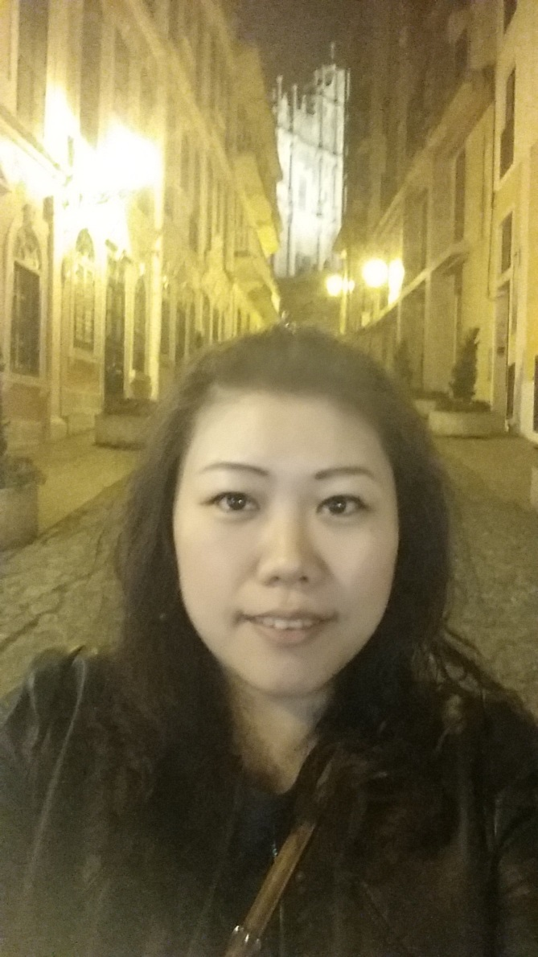

I am Lucy. I dreamed to be a teacher when I was young. Since I graduated, I started to teach children. When I teach, I always share my teaching experiences and now I teach teachers how to teach efficiently and easily. Teaching becomes part of my life. Join us, be a teacher.

**Education:**

University of Ming Chuan, BA

**Employment:**

2010-Present:

English Education Center Head Office

Academic Affairs Head Office

2002-2010:

English Teacher and Head Teacher

Lucy Lu